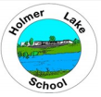
HOLMER LAKE PRIMARY SCHOOL
SEND Newsletter
March 2026
SEND Review Meetings

Parents evening is taking place on Wednesday 25th March. At this meeting, your child’s second SEND review for this school year will take place. Your child’s class teacher will discuss your child’s provision map, reviewing, and assessing (Review and Assess) your child’s progress from the beginning of the Spring Term.
A copy of your child’s provision map for Spring Term will be sent home.
If you have any concerns or would like to discuss your child’s needs further, please speak to your child’s class teacher.
At Holmer Lake Primary School, our children are at the centre of everything we do. We aim to identify the needs of all pupils as early as possible. This is part of our graduated approach, in which we Assess, Plan, Do, Review. This ongoing cycle ensures that effective provision is put in place and removes barriers to learning. We have a range of interventions taking place daily in our school to meet the needs of all our children. We believe in inclusivity for all and strive to make this a reality for all our pupils.

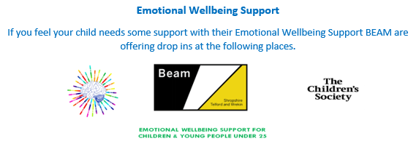
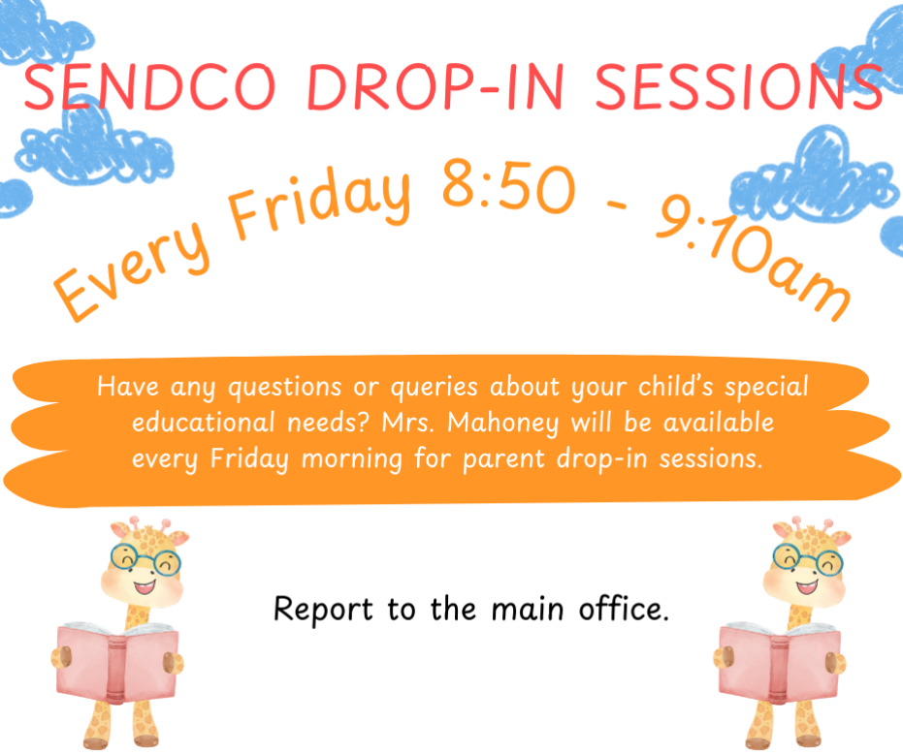



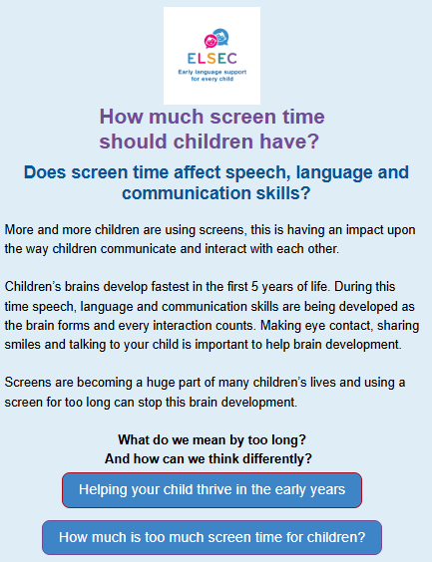



Scan the QR codes to find out more
SEND Information
School’s SEND Offer:
http://www.holmerlakeprimary.org/key-information/send
Telford & Wrekin SEND Local Offer:
https://www.telfordsend.org.uk/site/index.php





